Police Unity Tour Chapter IX
2024 Ride
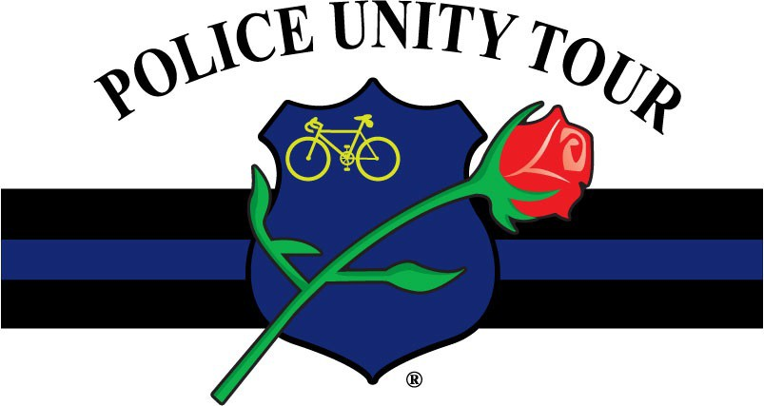

Ride Itinerary

May 8th—Arrive at the Host Hotel, iPennsylvania.
Check-in, Orientation, Mandatory Meetings.

May 9th—Depart Pennsylvania & Ride to Delaware

May 10th—Depart Delaware & Ride to Aberdeen, Maryland.

May 11th—Depart Aberdeen, Md & Ride to Columbia, Md

May 12th - Depart Columbia, Md. & Ride to D.C. (Approximately
45 miles)

Police Unity Tour Arrival Ceremony at NLEOM—2:30 pm

1

Mission
The Primary purpose of the Police Unity Tour is to raise awareness of Law Enforcement Officers who have died in the line of duty. The secondary purpose is to raise funds for the National Law Enforcement Officer’s Memorial and National Law Enforcement Museum.

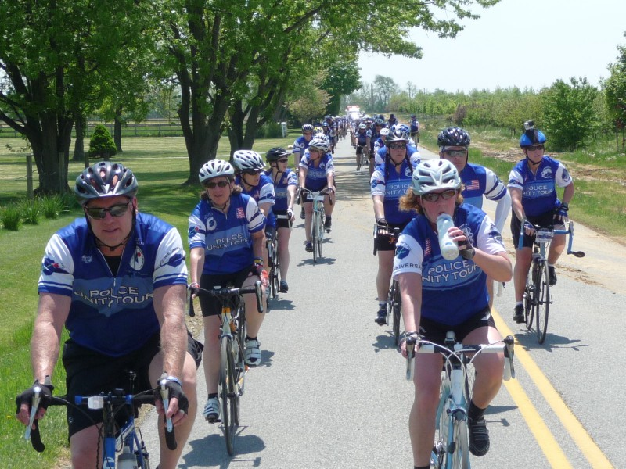

Fundraising
Each Rider is required to raise a minimum of $ 2,100 in order to participate in the Tour. Support members must raise $2000. Within 45 days of your application being approved, you must submit $500 in sponsorship funds. All members must have $900 by February 15, 2024. ALL MEMBERS must raise their entire funds by April 1st ,2024. Donations raised by the Chapter or by a member are not transferable to another member. All donations raised and fees paid are not refundable in the event that the minimum is not met or the member cannot participate in the Tour. No donations raised may be utilized for personal expenses, or transferred to the next year.

A completed sponsor form, in the forms section of the website, must be submitted with each donation received offline in order to accurately credit you and your sponsors. Donations are tax deductible. Our tax identification number is 35-2423027. Please fill out the form completely so that we may provide members with an accurate record of contributions. Checks are made out to Police Unity Tour, Inc. (not to an individual) Mail the form and the donation to:

Police Unity Tour
P.O. Box 381 Hockessin, De 19707

Members can also ask sponsors to submit donations directly through the Police Unity Tour, Chapter IX website. The donor can choose the members name from a drop-down box. Donating directly through our website does incur a PayPal administrative fees of 2.7% plus 30 cents for every donation made, but is very convenient for some sponsors.

Sponsors who donate $1,000 or more will receive a commemorative plaque after the ride IF a sponsor form is filled out and submitted. Clearly print the sponsor’s name or business on the form, as they would like it to appear on the plaque.

Members are encouraged to raise as much money as possible. As cost rise, so do the expenses of operating the Tour.

Training and Equipment

It is the member’ s responsibility to be in condition to complete the Tour. New riders must complete an evaluation ride prior to acceptance.

It is recommended that you train with an experienced Tour rider, if possible, and become familiar with riding in a group. Ride in areas that have some hills and work on your hill climbing. Before the Tour starts you should feel comfortable riding 40 miles of mixed flats and hills at an average pace of 15 mph. Work on your riding technique and on feeling comfortable handling your bicycle.

Riders who are unable to maintain the pace will be removed from the roadway until they are able to continue at the required pace. If they are unable to meet the required pace due to injury or lack of physical ability, they will be moved to a support position. While the Tour is not a race, it is necessary to maintain a reasonable pace due to road permits, and other time constraints. Safety precautions also require that all riders stay in a well-formed group.
Nutrition and hydration are important during training as well as on the Tour. Be aware of maintaining your electrolyte consumption.

Bicycle Maintenance
A professional bicycle fitting is recommended. Riders MUST have their bikes professionally tuned and serviced just prior to the ride. If your bike is not mechanical sound, you will not be able to participate as a rider. Advise the bike shop that you will be participating in a high mileage cycling event and have them pay particular attention to the wheels, tires, brakes, chain rings, and shifting mechanism.
Chapter IX will provide routine bicycle repair parts during the Tour. If your bicycle has specialized parts that we may not stock, you should bring those replacement parts with you. Every rider should have two spare tubes just in case the Tour runs low.
Rest Stops
There will be breaks approximately every 16-22 miles. Water, Gatorade, fruit, and various snacks will be available.
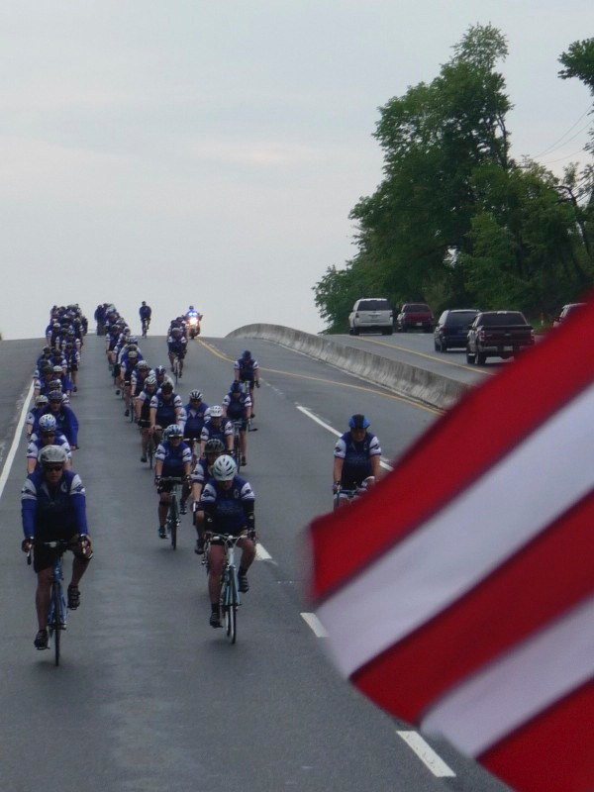

When departing a rest stop, line up in an orderly manner.
Use the portable restrooms provided at the breaks. It is unacceptable to urinate in the woods or in public view.

Safety
Helmets less than five years old and eye protection are required at all times while riding your bike. Calling out road hazards and notifying fellow riders of slowing and stopping are critical to everyone’s safety.

Due to the critical nature of communication while riding in a tight group, and the necessity to be able to quickly react to that communication, IPods or entertainment devices which use earplugs, earbuds, or headphones are strictly prohibited (with the exception for ride marshals selected to wear radio ear piece to assist in the pace and escort of the group).

Tandem or recumbent bicycles are prohibited, as are aerobars.

DO NOT pass the Motor on your left and do not pass riders on their right. During either of these moves creates a serious safety hazard. Do not pass the lead vehicle or the lead (pacing) riders, and PLEASE DO NOT request that the pace be changed. Tour officials set the pace to ensure rider safety and accommodate cyclist of various skill levels while maintaining unity.

Riders must ride two by two, unless otherwise directed. If a rider experiences a mechanical issue they are to pull onto the right shoulder and wait to be picked up by the mechanical trailer. Once the issue is resolved the repair trailer will drop the rider back with the group.

Riders who cannot keep up with the group, or fall to far behind the end of the group will be asked to get into the pick-up vehicle until the next rest stop. This request MUST be honored for the safety of all the participants. A rider who consistently falls behind will be asked to join the support team for that day or for the remainder of the ride. Safety comes first and being a Support Team Member is just as important as riding!!

Ride Marshals
Ride Marshals are assigned to assist and monitors riders. They will be wearing visible helmet covers and typically ride to the left of the group, between the motors and the cyclist. DO NOT pass a ride marshal on their left. This will place you in the way of the motors and is a very serious violation.

Ride Marshals are there for your safety and assistance, they are experienced PUT riders, and are official representatives of the Police Unity Tour. They have the authority to enforce rules set forth by the Executive Board and are to be obeyed at all times.

Transportation & Lodging

All members must arrive to the Host Hotel in Pa. by May 8th at or prior to 3 PM
The Police Unity Tour, Chapter IX provides hotel rooms as follows:
May 9th- in Delaware
May 10th in Aberdeen, Md.
May 11th in Columbia, Md.
May 12 thru May 14th in Washington, D.C. area.

The Tour DOES NOT pay for any incidentals (hotel movies, phone calls, room service) or damage to the rooms.

Prior to the Tour’s departure, members are responsible for the payment of their Host Hotel
room in Pennsylvania. It is YOUR responsibility to book a room at the sendoff hotel by the posted date.

All members must complete the hotel information section on the application. Members may request a roommate at this time or later if there are changes. You will be assigned a roommate if one is not specified on your application or by the time that assignments are being made.

If you ARE NOT staying in DC or only intend on staying the evening of the 13th, PLEASE let us know. These rooms are very expensive and if we know far enough in advance we can drop a room and therefore save the cost of that room.

Family Rooms in DC
If extra rooms are available for the Tour, then we will extend these rooms to our members on a first come, first pay basis. The cost of a family room is 1/2 of the Tour’s cost per night. The rooms MUST be paid for in advance and checks made out to the Tour. The cost of the room is nonrefundable and final hotel payment is due no later than two weeks after permission is granted. We cannot guarantee the availability of extra rooms, but will notify our members ASAP as to Family Room Availability.

Host Hotel for Pennsylvania
PUT members will have a group rate at this hotel. Please check the website frequently to see the updates as to the reservation link for the hotel and the date that the room must be booked by.

The closest airport is Philadelphia International Airport. For members who are flying into the area to participate in Chapter IX’s route. We will work on having transportation for those flying in, but it is not guaranteed that we will be able to procure this.

If you need to ship your bike, send it to the host hotel. Make sure to leave plenty of time for shipping and notify the hotel that your bike is on its way.

Please include your name and your Department on the bike box. Bike mechanics will be available to assist you with assembly at the hotel. Once we arrive in D.C., you will be able to obtain your bike box and the disassembly and packing of your bike will be your responsibility. Our mechanics will gladly repack your bike upon request.

Support

Our Support Team Members are crucial to the Police Unity Tour’s mission; without support we could not ride!

Support consists of Hotel, Break, Procession, and Motor. If you are one of support team members you will be notified of the Team to which you have been assigned prior to the start of the Tour. We place members on certain Teams based on our need.

Motor Support Team: primary purpose is the safety of the ride. They block intersections, ramps, driveways, and ride alongside the cyclist monitoring their safety.

Hotel Support Team: ensures that the luggage is loaded onto the vehicles every morning, and transported to the destination hotel. Once at the hotel the hotel team members will work with the hotel staff to assign the rooms, obtain the room keys, and then place your luggage in your room. They will ensure that important times and information is posted in the hotel lobby, such as dinner and breakfast times and departure time for the next day.

Break Support Team: travels ahead of the procession to each rest stop to ensure that the cyclist and other members of the procession are able to have immediate access to nutrition and hydration. Break support also makes sure that the rest area is clean after the procession departs so that we are welcome back the following year!

Procession Support Team: entails the remainder of the support crew, and each member has a different function, but all are there for the immediate support of the cyclist while they are pedaling. These members include the lead vehicle driver and navigator, bike mechanics, safety vehicle, drop van driver, mechanical trailer driver, ambulance crew, an any other drivers assigned to the procession.
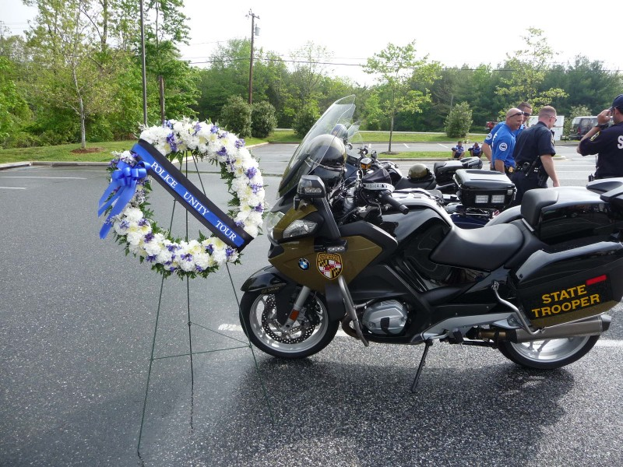

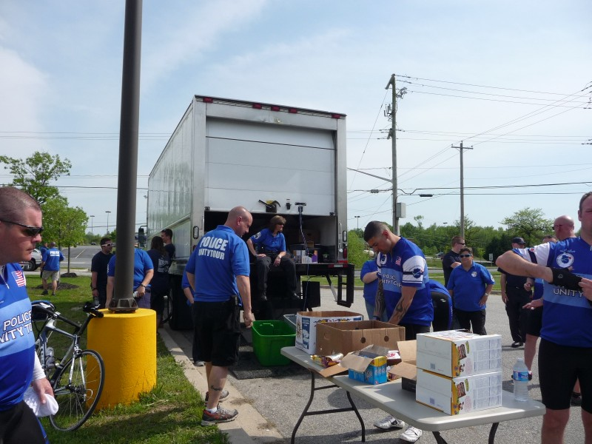

Uniforms
Riders will wear a blue Police Unity Tour Jersey,
black shorts (plain, no designs) or pants, helmet and eye protection.

Department patches may only be sewn on the center back pocket of the jersey. They may not be sewn at all on the Anniversary jersey.

Do not cut or alter the jerseys, do not roll the sleeves on the jerseys up while riding.

Do not put any advertisements on the jerseys, jackets, or any other part of the uniforms. This applies to riders, motors and support personnel.

Jerseys and jackets are to be worn by Tour members only. They are NOT to be sold or given to nonmembers.

There is no rank on the Tour. Your rank should not appear on your name tag.

It is recommended that each rider have at least two jerseys and that support have two support shirts. This allows for a clean jersey/shirt to be available each day.

Once your application has been processed, you will have access to the uniform purchase forms.

Support members will wear a blue Police Unity Tour polo shirt and black or tan pants or shorts. Department patches may be sewn on the left sleeve.

All members who are not wearing their Class A uniform to the Vigil are requested to wear their Police Unity Tour jersey, polo shirt, or jacket.

The blue and white jacket can be ordered through Bikeland II using the order form available on the website.
All other uniforms can be purchased by completing the uniform order form, found under the Members Only tab on the website, or via our online store. Orders will not be processed until payment is received.

Meals

Meals Provided by the Tour are as follows:

May 9th -Breakfast, Lunch, Dinner, May 10th - Breakfast, Lunch, Dinner, May11th - Breakfast, Lunch, Dinner(Dinner may be on your own on this date), May. 12th - Breakfast, small Lunch/ snacks
All meals in D.C. are the responsibility of the member.

On May 8th, during Registration, Chapter IX will host a “Meet and Greet” at the Hosting Hotel. This will be a great opportunity grab at light bite to eat, meet and socialize with others, sell/buy merchandise, and get any questions you may have answered.

Luggage
Luggage must be labeled with each member’s name. Each evening your bags will be delivered to your hotel and brought to your room. If luggage is misdirected to your room, please bring it to a hotel team member in the lobby immediately. We will have luggage tags available upon check-in on the 8th.

If you are bringing a garment bag that you will not need until arrival in DC be sure to tag the bag accordingly and notify the support team member who is assisting you with check in or loading the luggage on the trucks. That piece will not be taken off the truck until we arrive in DC.

When packing keep the weight of your luggage to a minimum! Remember that support team members will be moving that luggage everyday to ensure it gets in your room each night.

Members are required to place their luggage on the appropriate truck at the designated time each morning.

Weapons are not to be transported in your luggage! We have weapon lockers available. We are not responsible for weapons lost or left in luggage.

For your convenience, easels will be in each hotel lobby with meal, luggage and departure information.
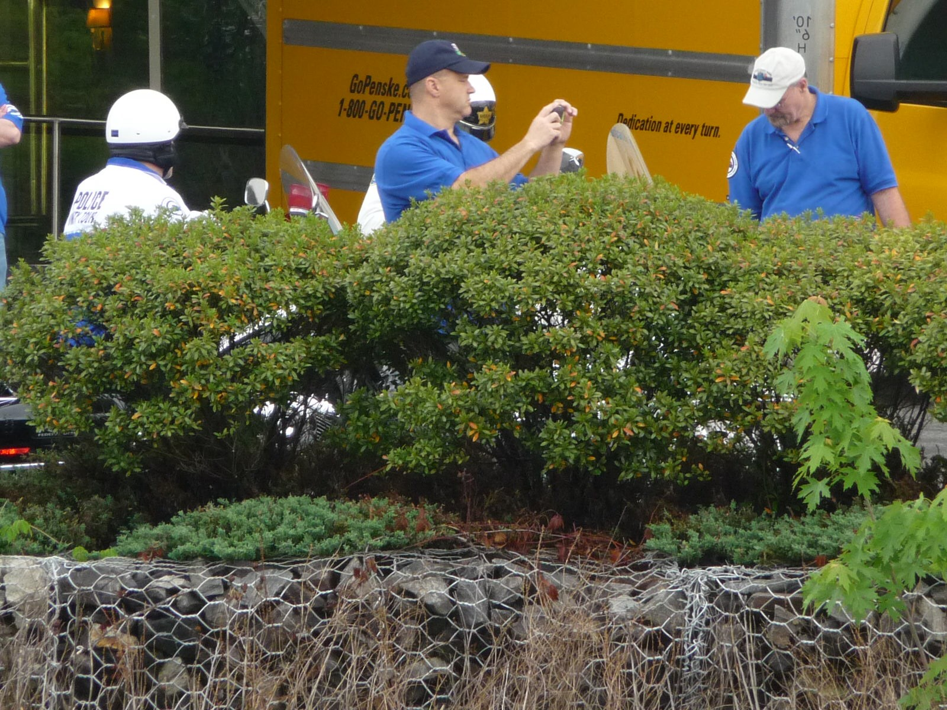

Memorial Bracelets
Each member is encouraged to purchase a memorial bracelet with the name of an officer or Canine who died in the calendar year or years preceding the Tour. You may also purchase more than one bracelet and ride for more than one officer.

It is Tour Member’s responsibility to contact the officer’s department and family to inform them about the Police Unity Tour. Arrangements may be made to meet the deceased officer’s family and/or department members at the Memorial and present the bracelet to them. If they are unable to meet you, the bracelet should be mailed to them upon completion of the Tour.

You can special order bracelets for an officer that died in a previous calendar year or in the current year
at. Please have the full name, rank, department and EOW date. If you are in doubt, please utilize the Officer Down Link on our home page and search for your officer.

There is a link on the website in the members only section for Bracelet orders.

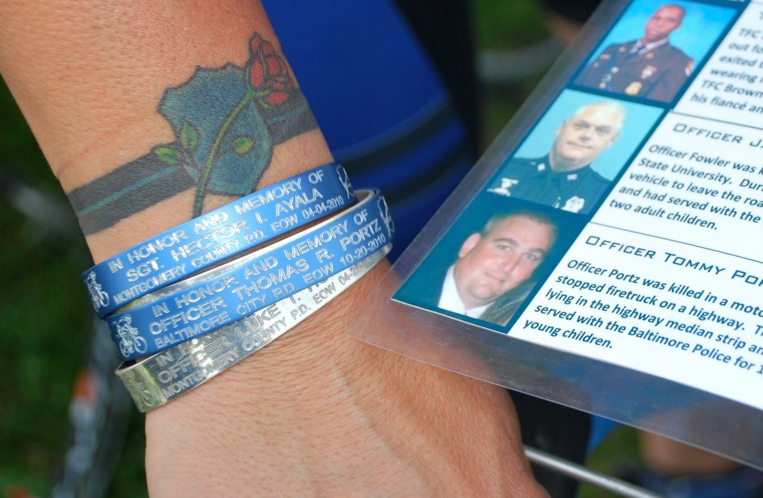

Survivor Escorts

The Police Unity Tour has the honor of escorting the survivors during the Candlelight Vigil on Oct. 14th. This is an incredible honor and experience and it is recommended that all officers experience it at least once.
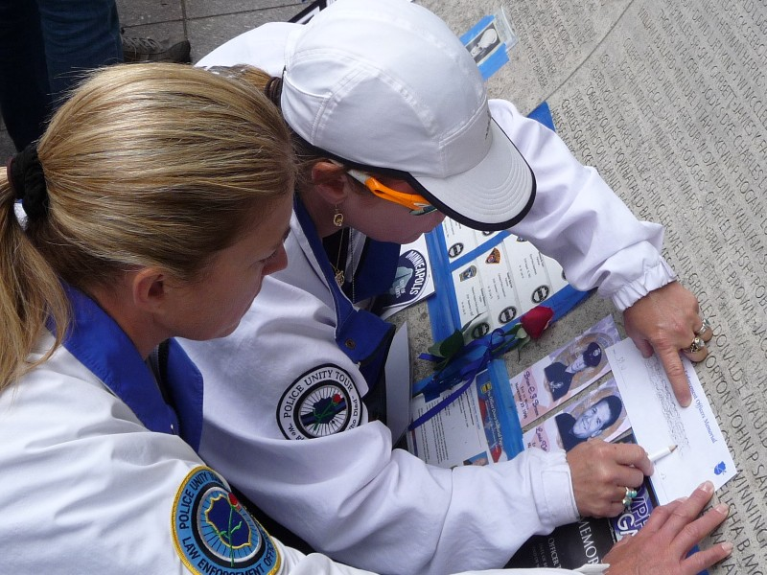
Class A uniforms with white gloves MUST be worn to participate as an Escort. Information will be sent out when names are being taken for consideration as an Escort. If Retired you may wear a suit with your badge displayed.

All Police Unity Tour members are EXPECTED to attend the Candlelight Vigil. For those not performing Escort duty, we request that you wear either your Jersey, the Unity Tour Polo shirt, or the Unity Tour Jacket.
